Secure Settings
Identify Options Procedure

Revision
Version 2
9/4/25 11:02 AM

SME
Charles Wilson

Abstract
This document describes the procedure used to perform the security option identification activity described in the AVCDL ^{[1]} secondary document Secure Settings Document ^{[2]}.

Group / Owner
Security / Security Architect

Motivation
This document is motivated by the need to ensure that the software is built with tools whose selected settings are based on cybersecurity best practices. This is necessary given the nature of safety-critical, cyber-physical systems
Note: Within the context of this document, the terms security and cybersecurity are used interchangeably. It is presumed that the term security is being used in reference to cybersecurity and not physical security.

License
This work was created by Torc Robotics and is licensed under the Creative Commons Attribution-Share Alike (CC BY-SA-4.0) License.
https://creativecommons.org/licenses/by/4.0/legalcode

Audience
The audience of this document is the cybersecurity practitioner who will be conducting cybersecurity-specific tool setting options identification.

Completeness of Output
Since the identification of security options is an as-is analysis, it is critical to ensure that the information gathered is as accurate and complete as possible. As with any cybersecurity activity, it is not the place of the cybersecurity SME to make unsupported assertions. All information should be based on the best available sources and confirmed where possible prior to inclusion.
Note: When information is not available for either a given section of the template or parts thereof, this should be noted.

Disposition of Output
Once completed, the generated output should be managed in the organization’s document management system (DMS) as a document of record.

Entry Criteria
This document assumes that the reader understands the purpose of cybersecurity-relevant tool settings. Further, that the reader has read and understood the AVCDL Secure Settings Document secondary document.

Prerequisites – Security SME

Qualifications
It is required that the cybersecurity SME is both a qualified and trained security architect (shown above on title page as Owner) as defined by the NIST NCWF role SP-ARC-002 and detailed in section 12.7 Security Architect of the AVCDL primary document ^{[1]}.

Knowledge
It is required that the cybersecurity SME understands the purpose of cybersecurity-relevant tool settings.

Background Information
It is required that the cybersecurity SME has read and understands the AVCDL Secure Settings Document ^{[2]} secondary document. Additionally, that the cybersecurity SME has taken training relevant to this activity.

Prerequisites – Input Materials
It is required that the development group provide all relevant documentation related to the tool under consideration necessary to complete the procedure.

Identify Security Options Activity
The workflow diagram for the identify security options activity of the Secure Settings Document is shown below.
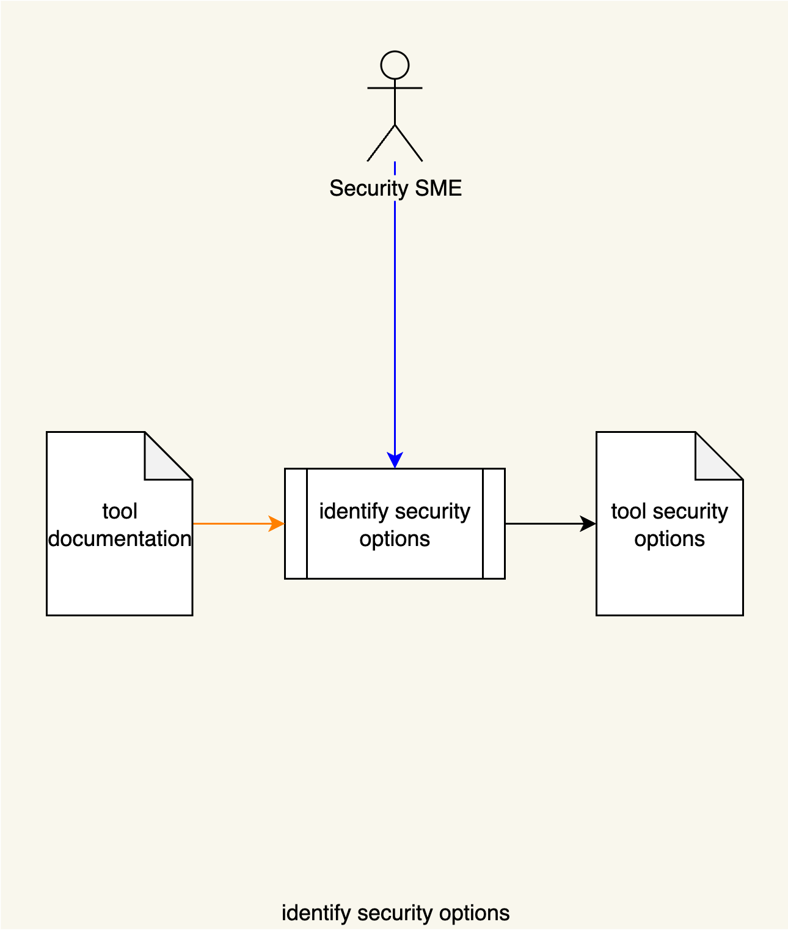
The Security SME reviews the Tool Documentation and identifies the cybersecurity options. The identified options are put in a Tool Security Options list.
The Tool Documentation may come from numerous sources including, but not limited to:
- Hardcopy
- Online (vendor site)
- Source code

Each entry in the Tool Security Options list is minimally composed of the following information:
- Option
- Description of the option
- Security relevance
- Bug Class
The set of bug class values is taken from the NIST Bugs Framework ^{[4]} document.
Note: The list may contain additional information as appropriate to the type of tool.

NIST Bug Classes
The NIST Bugs Framework provides a failure taxonomy which is useful in determining which cybersecurity-relevant options to focus on. This information will be used in later activities within the secure setting process.
The bug classes are:

Input
- Validation
- Verification

Memory
- Addressing
- Management
- Use

Data
- Declaration
- Name Resolution
- Type Computation
- Type Conversion
Note: It is assumed that not all tools will have cybersecurity-relevant options covering all bug classes.

Methodology
The methodology for this activity is straightforward.
All available documentation is reviewed and a list of options is assembled.
Note: It is important to include all of the tool’s cybersecurity-relevant options, even those which may not be applicable to specific products. Later activities will tailor the list to those which are deemed appropriate.

Tool Security Options Template
The element cybersecurity requirements catalog may be documented using the AVCDL tool cybersecurity options template Microsoft Excel workbook ^{[3]}.
Note: Other forms of documentation are permissible so long as they provide the information laid out in this document.
There are five sheets in the workbook. They are:
- Cover sheet
- Revision history
- Reference documents
- Options
- Legend
These will be addressed in turn.

Duplication of Rows in the Various Sheets
When there is the need to add rows to the various sheets of the workbook, be sure to duplicate an existing row. This is because validation checks are attached to some of the cells which also enables the use of dropdown lists.

Cover Sheet
The cover sheet of the workbook is shown below:
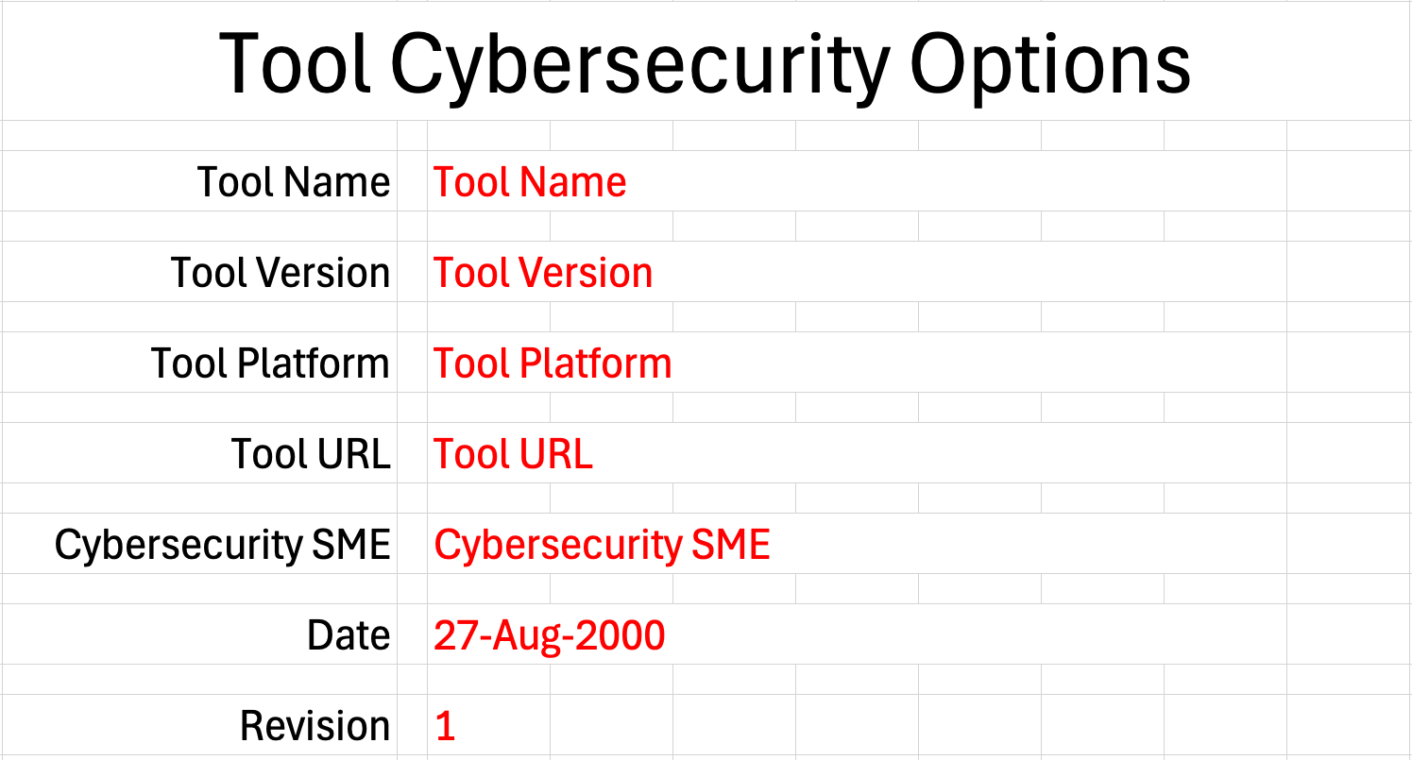
Fields to be completed are shown in red.

Tool Name
This is the name of the tool whose cybersecurity options are being identified.

Tool Version
This is version number of the tool under consideration.

Tool Platform
This is the platform on which the tool is run.

Tool URL
This is location where the tool can be found.

Cybersecurity SME
This is the cybersecurity subject matter expert creating the options list.

Date
This is the date when the options list was created or updated. The date should be updated whenever the list is updated.

Revision
This is the revision number of the document. The revision number is a monotonic and increasing integer, starting at 1. It should be incremented every time the document is updated.

Revision History
The revision history sheet of the workbook is shown below:
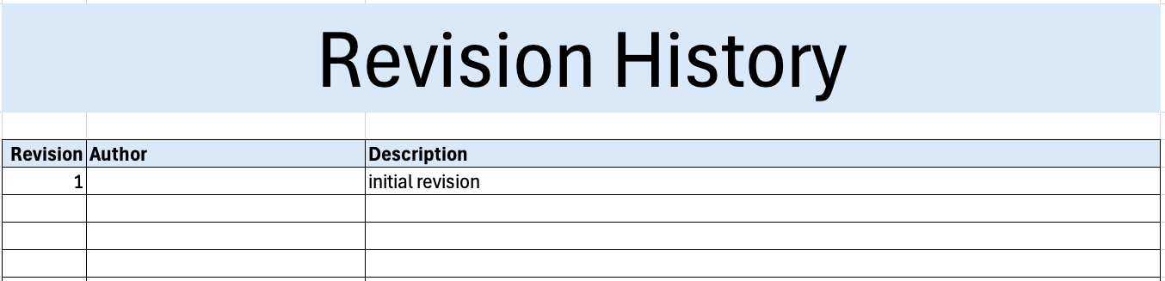

Revision
The revision corresponds to that listed on the cover sheet.

Author
The author corresponds to the cybersecurity SME listed on the cover sheet.

Description
This is a brief description of changes made to the workbook since it was last updated.

Reference Documents
Note: These references are those necessary for the creation of the cybersecurity options list.
The references sheet of the workbook is shown below:
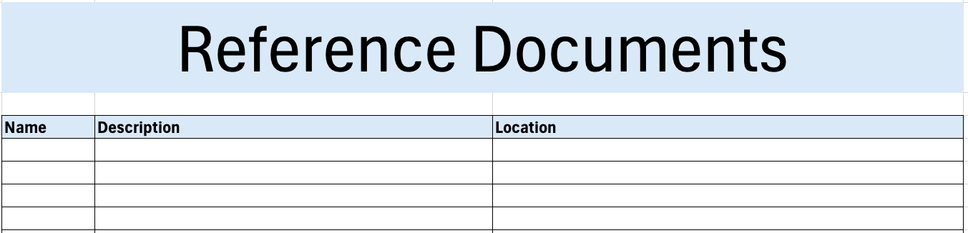

Name
This is the name of the document being referenced.

Description
This is a brief description of the document being referenced.
Note: In cases where the reference material is expressed in the form other than a document (for example, a web page), this should be noted.

Location
This is the location of the document being referenced. It may be a physical location or a URL.

Options
The options sheet of the workbook is shown below:
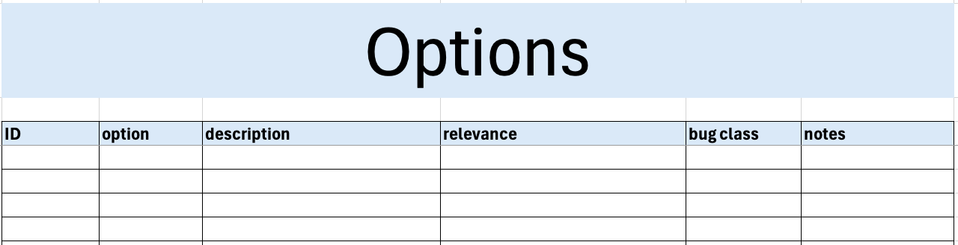

ID
This is the unique ID of the option.

Option
This is the name of the option.

Description
This is the description of the option.

Relevance
This field describes why the options is relevant from a cybersecurity perspective.

Bug Class
This is the NIST bug class of the option.

Notes
This is a general notes field.

Legend
The legend sheet of the workbook is shown below:
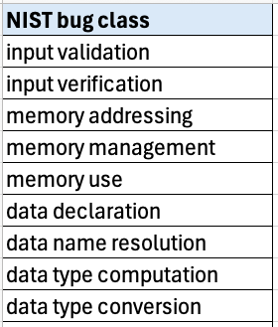
The legend sheet information is used to make the completion of the document easier by providing dropdown lists for common values. It also ensures that spelling errors do not creep into the generated material.
Note: The legend sheet should not be edited. If an unlisted value is required, the template should be separately revised.

Exit Criteria
This procedure is considered complete once the generated output has been entered into the organization’s DMS as a document of record.
Note: The processes and procedures for entering documents into the DMS, or the updating thereof, are outside the scope of this document.

References
- AVCDL (AVCDL primary document)
- Secure Settings Document (AVCDL secondary document)
- AVCDL tool cybersecurity options template (AVCDL template)
- NIST SP 800-231 Bugs Framework (BF): Formalizing Cybersecurity Weaknesses and Vulnerabilities
https://nvlpubs.nist.gov/nistpubs/SpecialPublications/NIST.SP.800-231.pdf

